Machine Learning-Based Smart Health Assistant Systems for Early Disease Diagnosis and Specialist Mapping: A PRISMA-Guided Review
Sharif Ahmmed Nazmuzzaman, Iftakhar Ahmed Rakib, Arman Al Arefin, Golam Rabbani, Sayeda Anika Tasnim, Rifath Mahmud, and Tanvir Ahmed.

Abstract- Machine learning is being used more and more to not only predict disease, but also to provide symptom checking support, conversational support, triage and referral-oriented decision support. This wider trend is important as it will mean that smart health assistants will be a major topic of research, particularly when users will seek help prior to formal clinical consultation.
In this review, 65 papers are reviewed to see how far the literature has developed towards integrated smart health assistant systems that can help in the early diagnosis, safe guidance and specialist mapping.
The literature was synthesised using PRISMA guided review approach. Transparency of eligibility, extraction and thematic analysis procedures were employed to screen and synthesise the papers in the corpus of 65 papers. Evidence was organized into foundational reviews, structured data disease prediction systems, general systems for disease prediction, symptom-based systems, disease-specific systems, chatbot and assistant systems, and triage/referral studies.
Literature indicates that predictive modelling has made significant strides and user facing tools are of interest. The field is, however, still very fragmented. While many of the studies focus on optimising the classification or prototype functionality, fewer involve a combination of symptom intake, uncertainty aware interpretation, safe triage, explanation and specialist recommendation in one coherent system. Other Ssignificant concerns include the potential for inaccurate drug recommendations, insufficient databases, incorrect confidence in the results, privacy, and dealing with abusive or manipulative user input.
Most promising research direction is the creation of clinically responsible smart health assistants that foster linkage between early symptom assessment and safe escalation and specialist mapping. Going forward, algorithmic performance and explainability, safety, regulation-aware design, and real-world validation need to be balanced.
Keywords: machine learning, healthcare AI, symptom checker, chatbot, triage, specialist recommendation, PRISMA-guided review, smart health assistant.

I Introduction
Machine learning is one of the most impactful lines of digital health care, as it can detect diagnostic trends from symptoms, lab results, imaging results, patient grievances, and other clinical data. However, recent research has demonstrated that it's not just a clinician-facing decision tool anymore. It's now moving into patient-facing health checkers, primary-care apps, chatbots, and recommendation systems that are designed to speed up and ease the process of providing early support [1], [3], [5]-[6], [10]-[12], [15]-[16], [18], [21], [24], [26]-[27], [30]-[31], [36], [43], [46], [48]-[49], [55]-[56], [61]. This change is significant because frequently access to health care issues occur before a diagnosis rather than after diagnosis.
When it comes to real first contact situations, users won't just want a prediction result. They typically require a series of assessments and support – how to assess for potential conditions, urgency of the situation, clear-cut advice for caution and guidance on to whom or what level of specialist support to refer the client. That order is important particularly in situations where access to clinical consultation may be limited, expensive, geographically distributed and/or disjointed. In this sense, the design problem is not just about the accuracy of model classification of disease, but also about the responsibility of model output that can be used to provide support to non-expert users.
The literature reviewed indicates that there are many of the required building blocks in the field. Strong evidence exists for structured-data diagnosis in imaging and laboratory-linked studies [1], [5]. Disease-specific prediction is also well developed across work on Alzheimer’s disease, chronic disease, heart disease, and headache disorders [2], [4], [7]-[8], [25], [37]. A separate stream focuses on symptom-based health checking and multi-disease reasoning, showing growing interest in early-stage user support [3], [16]-[17], [51]-[53]. Chatbot interaction and recommendation-oriented systems extend this logic toward conversational guidance, triage, and specialist referral [11]-[12], [19], [21], [24], [55]-[56].
Accordingly, this paper asks two connected questions. First, what has the literature achieved in machine learning-based disease diagnosis, symptom checking, assistant interaction, and referral support? Second, what remains unresolved if the aim is to develop an integrated smart health assistant for early diagnosis and specialist mapping? To answer these questions, the literature is synthesised through a PRISMA-guided structure that extends the discussion beyond prediction performance to include explanation, risk, regulation, and safe deployment. PRISMA 2020 provides a 27-item checklist, an abstract checklist, and flow diagrams to improve transparency in review reporting, and this paper uses that guidance to strengthen the structure and clarity of the review process [66]-[68].

II Review Methodology

A. Review design
A PRISMA guided structured review design was used. It was aimed at a transparent and a systematic presentation of the review process instead of a meta-analysis. PRISMA 2020 was used as the reporting framework because it offers a well-established structure for reporting the rationale for doing a review, how studies were selected, what information was extracted and how the findings were synthesized [66]-[68].
The review emphasizes machine learning-based smart health assistant systems for early diagnosis, triage, instant guidance to the user and mapping to the specialist based on the symptoms. Given that the paper is at the intersection of the three fields listed above, diagnostic modelling, digital health and conversational support, a critical thematic synthesis was considered more appropriate than a purely statistical aggregation approach.

B. Review questions
The review was guided by three questions:
- What forms of diagnostic and assistant-related functionality are most strongly represented in the literature?
- How far has the literature progressed toward integrated systems that combine diagnosis, triage, and referral support?
- What ethical, legal, safety, and deployment issues remain unresolved for patient-facing medical assistants?

C. Information sources and search approach
The review included 65 papers relevant to machine learning-based diagnosis, symptom support, triage, and specialist referral. The corpus includes studies available through publisher platforms and indexing environments represented in the reference list, including MDPI, Nature, Wiley, ScienceDirect, IEEE Xplore, ACL Anthology, PubMed, PeerJ, and related repositories. Many of the clinically stronger papers are hosted through established publishers such as Nature, Wiley, and ScienceDirect [1], [5], [16]-[17], [45], [49]. Other papers contribute assistant, prototype, or review perspectives that help widen the discussion around smart health assistant design [11]-[12], [18]-[24], [55]-[58].
To support a more transparent review structure, the studies were examined according to review-relevant concepts rather than discussed as a purely descriptive list. The conceptual search logic reflected the core topic combinations addressed by the corpus, including terms such as machine learning and disease diagnosis [6], [10], [31], symptom checker and triage [16], [30], medical assistant chatbot [18]-[20], and doctor recommendation or specialist referral [12], [21]-[22]. This strengthened the consistency and analytical clarity of the review.

D. Eligibility criteria
Studies were considered eligible if they addressed one or more of the following: machine learning in disease diagnosis; symptom-based diagnostic support; complaint-based health prediction; disease-specific diagnostic modelling; healthcare chatbot or assistant systems; triage tools; doctor recommendation systems; or primary-care decision support relevant to early diagnosis and referral. Review papers, surveys, original modelling studies, and prototype systems were all retained when they made a clear contribution to the smart health assistant problem space.
Studies were treated as lower-value evidence during synthesis when they provided limited methodological detail, weak validation, or poor transparency. Repeated reports of closely related studies were not treated as independent findings during interpretation, even when they remained in the citation structure. Accordingly, the interpretation of the literature was guided primarily by relevance and contribution rather than by record frequency alone.

E. Study selection and PRISMA flow summary
All 65 papers were screened for relevance to the review questions. Each record was checked against the scope of early diagnosis, symptom support, chatbot or assistant functionality, triage, or specialist referral. Papers that belonged to the corpus but overlapped substantially with repeated reports or near-duplicate records were retained for traceability in the reference structure but were interpreted cautiously during synthesis so that repeated evidence was not allowed to distort the substantive conclusions.
The study selection process is summarised below. Sixty-five records were available for review, 65 records were screened, 65 records underwent full-text consideration for relevance to the review question, and 65 records were retained in the structured synthesis. The main methodological caution concerned overlap and repeated reporting rather than simple exclusion. Table 1 presents a condensed summary of the identification, screening, eligibility, and inclusion stages [66]-[67].
PRISMA review stage | Count | Explanation
Records available for review | 65 | Papers assembled for the review topic.
Records screened | 65 | All papers were assessed against the review scope.
Full-text records considered | 65 | All records were read for relevance to diagnosis, assistant functionality, triage, or referral.
Records included in synthesis | 65 | All papers informed the final structured synthesis, with repeated reports interpreted cautiously rather than treated as independent findings.
Table 1. PRISMA-style flow summary of the review process.

F. Data extraction and synthesis
The main topic focus, input type, intended users, principal function and contribution to the smart health assistant question was extracted from each study. In practice this was simply recording if the study was of structured clinical data, symptom-based reasoning, disease specific prediction, chatbot interaction, triage or referral support. Some limitations were also identified such as use of limited data sets, prototype validation, limited interpretability, and limited real-world deployment logic.
The synthesis that was completed was a descriptive one with critical interpretation. Based on the functionality of the studies, the studies were classified into seven themes: foundational studies on using machine learning in diagnosis, structured data diagnostic models, general disease diagnosis and prediction systems, symptom-based health checker systems, disease-specific applications, AI medical assistant and chatbot systems, and triage or specialist recommendation systems. This design made it possible to keep the review broad but also to highlight the key area for integration, safety and 'first contact' usability.

III Characteristics of the Reviewed Literature
The literature reviewed is wide and yet related in its body of evidence. Some are high-level reviews that map the field of machine learning in healthcare [6], [10], [15], [31], [49], [55]-[58]. Others are empirical studies or prototype systems with a specific class of diseases, symptom processing or assistant functionality [2]-[5], [11]-[12], [17]-[25], [37] and [51]-[54]. As a pair they demonstrate that the field is not about machine learning just being able to classify disease. It is now far more focused on how predictive intelligence can be brought down to a tool which is usable, responsive and safe enough to be public facing.
Thematic distribution of literature reviewed is summarised in Table 2. The distribution validates two key attributes of the field. First, diagnostic modelling remains the dominant emphasis. Second, assistant behaviour, triage, and specialist recommendation are present but less mature, which helps explain why integrated smart health assistants remain underdeveloped.
Theme | Representative references | Dominant contribution | Main limitation
Foundational reviews on ML in diagnosis | [6], [10], [15], [31], [49], [55]-[58] | Explain the evolution, scope, and method landscape of diagnostic AI. | Often broad, but less specific about user-facing assistant design.
Structured-data diagnostic models | [1], [5] | Show strong performance using laboratory or imaging-linked inputs. | Depend on richer data than many first-contact users have.
General disease diagnosis and prediction systems | [9], [13], [39], [54], [58]-[59], [64] | Demonstrate broader diagnostic logic beyond a single disease class. | Often stop at prediction without guiding the next care step.
Symptom-based diagnostic and health checker systems | [3], [16]-[17], [28], [50]-[53], [60] | Model early user-reported complaints and multiple disease possibilities. | Face uncertainty, ambiguity, and triage risk.
Disease-specific machine learning applications | [2], [4], [7]-[8], [25], [37], [40], [47], [62]-[63], [65] | Provide strong evidence in narrow, well-defined domains. | Less suitable for open-ended first-contact assessment.
AI medical assistant and chatbot systems | [11], [18]-[20], [29], [41] | Address communication, accessibility, and conversational support. | Frequently remain prototype-oriented with limited validation.
Triage, decision support, and specialist recommendation systems | [12], [14], [21]-[24], [30], [42], [45]-[46] | Connect diagnosis to urgency assessment and referral pathways. | Still thinner and less mature than diagnosis-only literature.
Table 2. Thematic distribution and interpretive role of the 65 reviewed papers.
To provide a clearer picture of study variety, Table 3 lists selected representative papers from across the corpus. The examples show the methodological spread of the literature, ranging from surveys and systematic reviews to disease-specific models, symptom-based systems, and referral-oriented prototypes.
Reference | Study focus | Type of study | Primary input | Relevance to smart assistant design
[1] | Medical imaging diagnosis survey | Survey/review | Imaging data | Shows the strength of structured diagnostic AI.
[3] | Collaborative symptom-disease diagnosis | Original model | Symptoms and disease relations | Directly relevant to symptom-led early diagnosis.
[5] | Laboratory-test disease prediction | Original model | Lab variables | Illustrates structured-data diagnostic support.
[11] | Healthcare chatbot for medical suggestions | Prototype/application | User queries and symptoms | Highlights conversational support and user interaction.
[12] | Disease prediction and doctor recommendation | Prototype/application | Symptoms and disease outputs | Links diagnosis to referral logic.
[16] | Accuracy of symptom checker triage | Systematic review | Digital symptom checker outputs | Shows the safety importance of triage quality.
[25] | Decision support for primary headache | Original model | Questionnaire/clinical inputs | Shows targeted specialist decision support.
[51] | Symptom-based health checker benchmarking | Empirical evaluation | Clinical vignettes and symptom inputs | Demonstrates the challenge of diagnostic accuracy under uncertainty.
Table 3. Selected representative studies included in the review.

IV Machine Learning in Medical Diagnosis: Foundations and Evolution
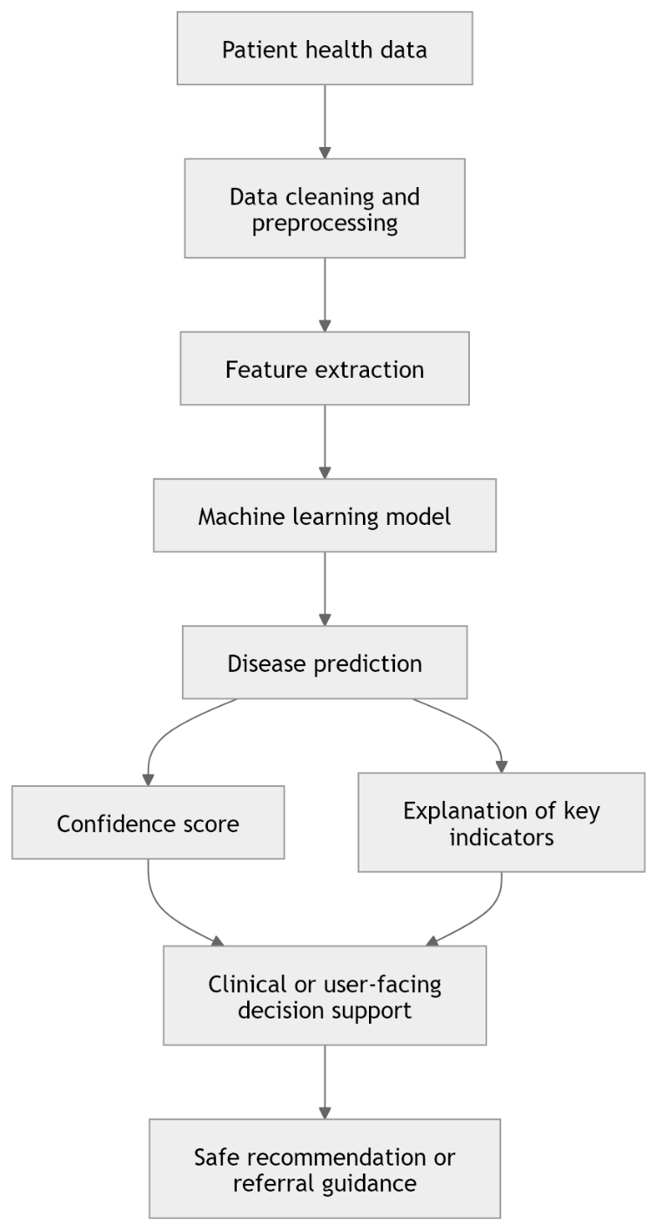
Figure 1. General machine learning-based medical diagnosis workflow.
The foundational reviews and surveys make it clear that machine learning has moved from an experimental analytical approach to a central pillar of diagnostic research [6], [10], [15], [31]. Broader field-mapping papers further show how comparative modelling, predictive analytics, and applied diagnostic pipelines have become standard parts of healthcare AI discussion [26]-[27], [36], [43], [48]-[49], [55]-[57], [61]. Across these papers, diagnosis is consistently framed as a pattern-recognition task in which symptoms, clinical variables, medical images, laboratory outputs, and patient histories can be translated into predictive features.
A second recurring message in the foundational literature is that algorithmic performance alone is insufficient. Reviews repeatedly draw attention to explainability, trust, data quality, bias, implementation barriers, and workflow fit [6], [10], [15], [31], [43], [48]-[49], [55]-[59]. Especially for patient-facing systems, such as smart health assistants, this is a concern, as patients are often not experts at using the system, and the system must be able to function in the presence of uncertainty. A classification outcome that may be appropriate for a trained clinician could be misinterpreted or upsetting if presented directly to the public, without being put in context, explained, and/or escalated.
The basic literature is thus a valuable background to provide an interpretive baseline. It's a testimony to the promise of diagnostic AI, as well as a reminder that a smart assistant isn't just about accuracy. It should be evaluated in terms of its ability to lead to safe, interpretable and context sensitive user support.

V Structured Data-Based Disease Prediction Models
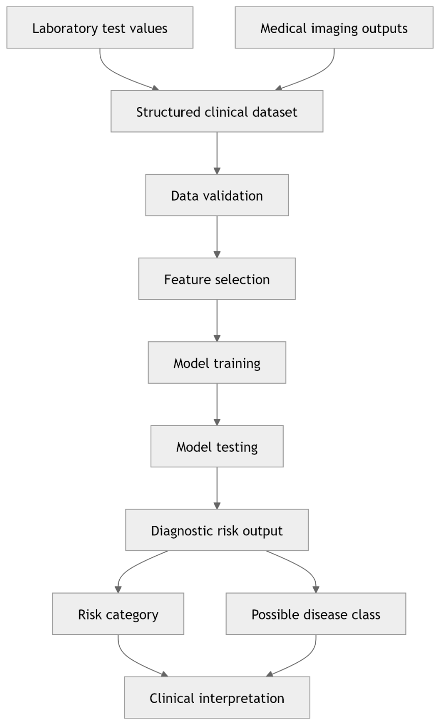
Figure 2. Structured data-based disease prediction pipeline.
The clearest technical evidence in the corpus is from research that utilizes inputs that are structured or contain extra clinical information such as laboratory data and medical imaging [1] [5]. These settings achieve better feature definition, greater stability of labelling, and better performance evaluation and thus often are the most methodologically solid of the results in the diagnostic literature. In some instances, with good input quality and precise disease categories, machine learning can be used to offer good risk stratification, reduce the diagnostic possibilities and be more consistent in supporting than manual interpretation.
The laboratory-test study is a good example of how traditional clinical parameters can be developed into models for disease prediction, which can then be used for prioritising the diagnostic possibilities [5]. The imaging survey also highlights the increasing integration of the use of machine learning in the disease recognition workflow of imaging. These studies make effective proof of the technical ceiling of Data-rich Diagnosis. They demonstrate the capabilities of machine learning in the best-case scenario where information is available.
Their strength at the same time reflects the limit. For example, smart health assistants designed to facilitate first contact support may start before a formal test or imaging can be carried out. This means that structured-data studies are very useful in the design of the model to support the diagnostic reasoning and early guidance for the user, but they will not, by themselves, solve the real-world problem of how to present early guidance to the user. Their work in the current review is thus more fundamental than comprehensive: they demonstrate the potential for diagnosis; they also demonstrate the need for designs that are based on symptoms and uncertainty.

VI General Disease Diagnosis and Prediction Systems
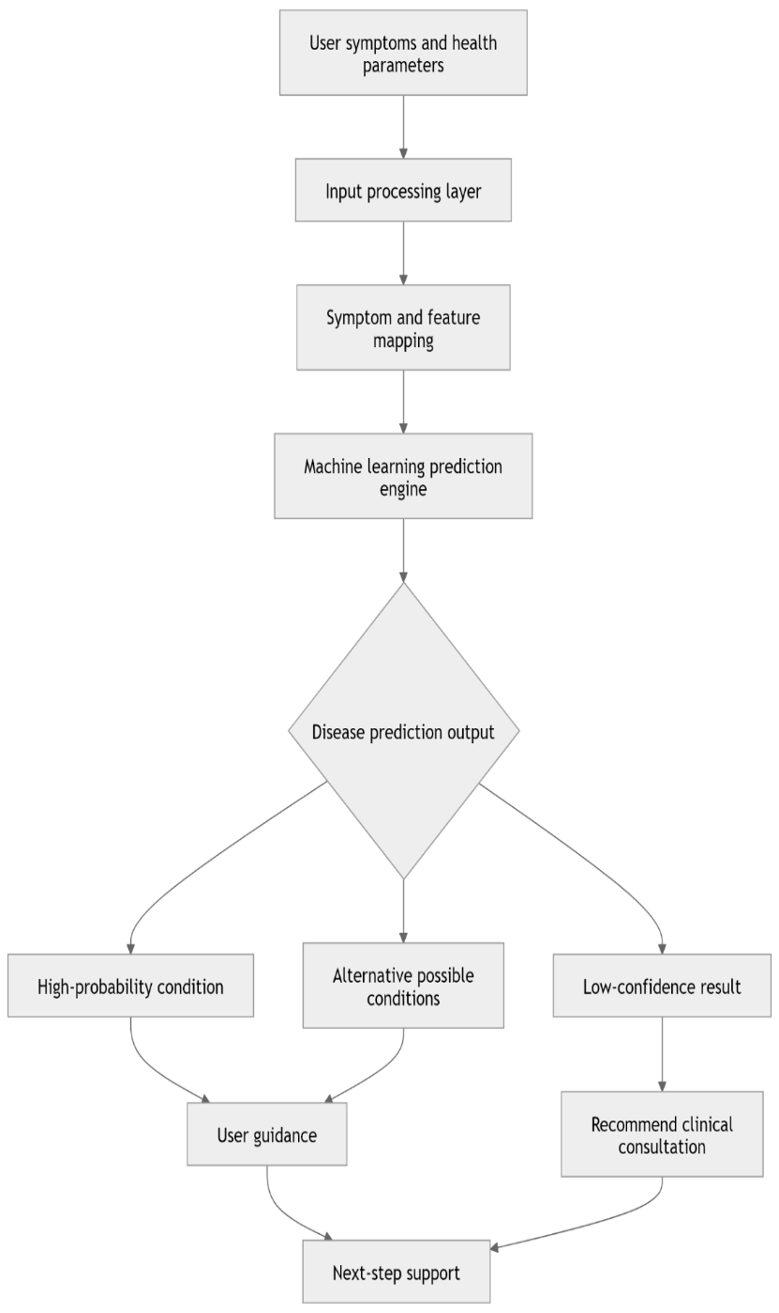
Figure 3. General disease diagnosis and prediction system architecture.
Other papers are about prediction of diseases in general or large disease domains [9], [13], [34], [39], [44], [54], [58]– [59] and [64]]. These studies are truly applicable in the design of smart health assistant, since this assistant cannot make an assumption that all the users belong to a predefined disease class. Rather it needs to work on a wider decision space and be able to interpret incomplete, open-ended or mixed symptom data.
In this stream, some papers focus on the performance of algorithms in comparison while the others mention the presentation of proof-of-concept systems or complaint-driven diagnosis models with real-life parameters [9, 13, 39, 54, 59, 64]. As a whole, they demonstrate an aspiration for more generalisable support tools, and less stand-alone clinical indicators. But many are still model centered. They show that prediction is possible, but are less focused on what user(s) should make of the prediction, how uncertainty should be expressed, or how the prediction should inform the next phase of care.
This is one of the key restrictions of the problem of smart assistants. A general model that predicts the disease may be interesting but of little use to the practitioner if the model doesn't tell him/her what to do next. Patient support-wise, prediction is incomplete if it is not done in the context of guidance.
Diagnostic and health checker systems based on symptoms in chapter 7.
The symptom-based literature is most similar to the practical logic of a smart health assistant since it begins with the kinds of complaints, uncertainty and limited arrays of self-reported signals [3] with which many real users begin. Further research on symptom checkers based on complaints, multi-disease prediction and benchmarked symptom checkers further enhances the relevance of this stream for the design of early support [29] [51-54] [61]. These studies delve into collaborative symptom-disease reasoning, classification based on questionnaires, health-checking workflow systems and multi-disease systems, and are thus particularly relevant to first-contact healthcare settings.
Especially in terms of accessibility, this theme is applicable. Use of symptom-driven systems may help to increase the scalability of early screening in situations in which formal consultation is challenging or delayed. Collaborative symptom-disease generation and multi-disease prediction demonstrate the potential of machine learning to go beyond a fixed set of symptoms and a rule tree [3, 17, 52-53]. Another indication of the performance improvement is by health checker benchmarking where it is systematically tested against clinical vignettes [51], [60].
However, symptom-based systems have the most difficult uncertainty issue of all the systems considered in this review. Symptoms are poorly described, subjective, vague and overlapping. There can also be significant differences in the use of the user language and this lack of clarity also contributes to linguistic and clinical ambiguity. Thus, it is the really responsible systems which make uncertainty visible and support safe escalation and not only output a likely label. For this reason, symptom-checker research should be assessed, not only for diagnostic performance, but also for the quality of the triage, risk of overconfidence, and how well it guides the user.

VII Disease-Specific Machine Learning Applications in Diagnosis
A considerable proportion of the literature reviewed was related to the application of the disease such as chronic disease [2] and heart disease [4] and headache disorders [7]-[8] and Alzheimer-related diagnosis [25], [33], [37], [40], [47], [62]-[63] and [65]. It is natural for people to have this concentration. Narrow tasks tend to generate cleaner data sets, more targeted feature engineering and evaluation of the results compared to a general first-contact system. This makes it very easy to draw some of the most obvious conclusions in healthcare machine learning with disease-specific studies.
These studies are very valuable. The chronic disease and heart disease models demonstrate the ability of machine learning to achieve good performance in a well-defined and clinically relevant target domain [4, 7–8, 37, 40, 62–63, 65]. The headache and Alzheimer studies provide evidence in the context of questionnaire-based and imaging-based settings [2] [25] [47]. They illustrate how model design to enhance prediction can be achieved in specific clinical areas.
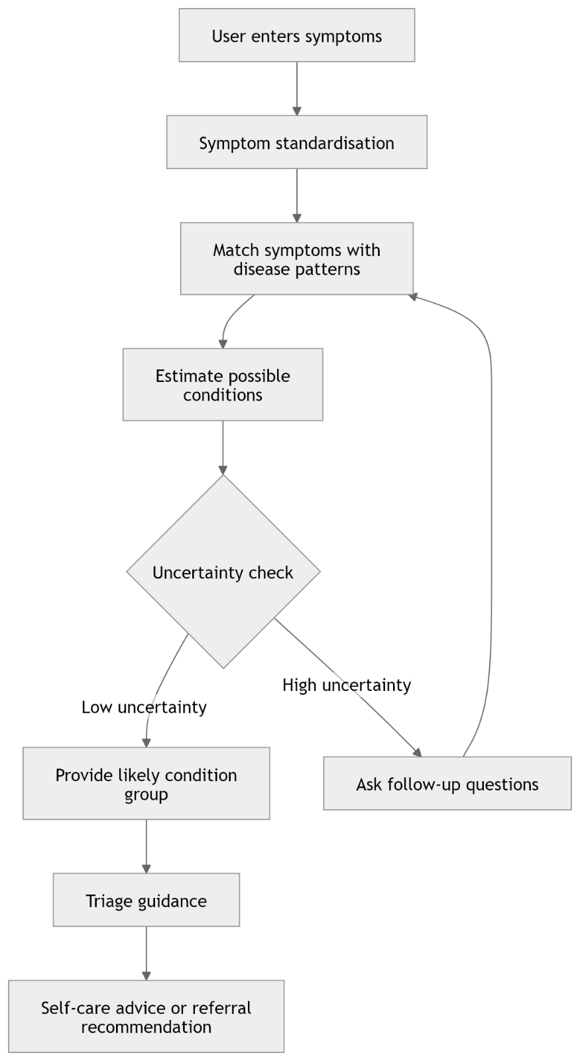
Figure 4. Symptom-based health checker workflow.
Yet, disease specific optimisation also shows the fundamental problem of this stream from the point of view of the design of smart assistants: The fact is that a user facing assistant cannot predict in advance to what class of diseases does a user belong. Initial contact assistance begins with a state of 'don't know' rather than a diagnosis. Disease-specific work is thus further proof of the technical feasibility of machine learning in healthcare, while not being sufficient for solving a comprehensive, multi-stage problem of early diagnosis, guidance, and referral, in a more extended symptom space.

VIII AI Medical Assistant and Healthcare Chatbot Systems
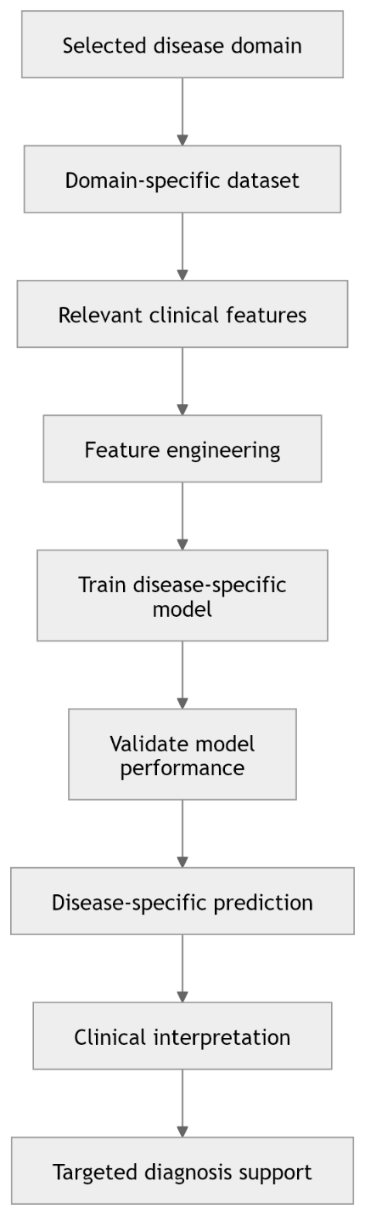
Figure 5. Disease-specific machine learning diagnosis framework.
How health-related support is provided to a user is another yet equally important issue the chatbot and assistant literature covers [11, 18-20, 29, 41]. The papers focus on personal healthcare chatbots, AI-based medical assistants, personalised assistant designs and medical communication context empathic response generation. Although they aren't necessarily as complex as high-performing diagnostic models, they are very important because they focus attention on the communication aspect of healthcare AI.
This is important because, although a system might make sense on the inside, it might flop if users are unable to articulate what they want the system to do, do not know what they will get from the system, or do not trust the system. Concerns that are brought up by assistants are conversational flow, empathy, accessibility, interpretive clarity, and user reassurance [11, 18-20, 29, 41]. When it comes to sensitive health matters, words matter. If not framed well, responses can heighten fear, promote misuses or be a source of misplaced confidence.
Most of the studies in the corpus are, however, prototype-based with a focus on the assistant. They frequently offer interesting interfaces or dialogue options and lack of multi-condition validation, strong escalation rules, and consistency with formal health care pathways. This indicates that although literature suggests promising potential of conversational support, it is not yet clinically reliable and ready for smart health assistant inclusion.

IX Triage, Decision Support, and Specialist Recommendation Systems
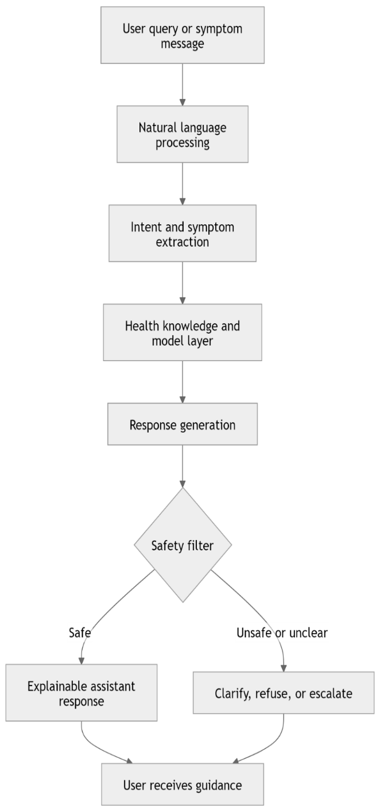
Figure 6. AI medical assistant and chatbot interaction architecture.
The triage and referral literature is one of the most strategically important components of the review as it starts the process of linking diagnosis to action [12, 14, 16]. This is further extended by doctor-recommendation and disease-to-specialist mapping studies, which enable prediction outputs to be connected with next step care choices [21]-[24],[30],[42]. Additional evidence is based on clinical decision-support and modelling studies in primary-care settings which highlight routing, risk management and care escalation [45-46].
Such a difference is critical. It's not necessary for a user to have a possible label only. The user should be aware if the situation is likely to be an emergency, if self-care is appropriate, if specialist advice is required and what type of specialist the most appropriate destination is [12,14,16,21-24,30,42,45-46]. The triage and referral functions are in the heart of the smart health assistant concept because they transform the diagnostic outputs to care pathways.
Although important, these studies are still less and less developed than diagnosis-only studies. Also, the systematic review of the accuracy of digital symptom checkers for triage is a cautionary tale, since to some extent an incorrect diagnostic guess is less dangerous than a poor triage [16]. So, it seems that it is not advisable to consider referral intelligence as a nice to have extra component. It should be considered as an integral part of any assistant which is meant for real users as a clinical safety layer.

X Ethical, Legal, and Safety Considerations of Smart Health Assistants
The reviewed literature suggests that technical performance alone is not an adequate basis for evaluating smart health assistants. Once a system begins to interact directly with users about symptoms, urgency, next-step care, or possible treatment options, ethical, legal, and safety issues become central rather than peripheral. This is particularly true in healthcare, where poor advice can delay treatment, create false reassurance, generate unnecessary panic, or expose users to harm. The reviewed studies repeatedly raise concerns about explainability, reliability, and deployment, but the assistant-specific implications of those concerns deserve explicit treatment [6], [10], [15], [16], [18], [27], [43], [55]-[59].
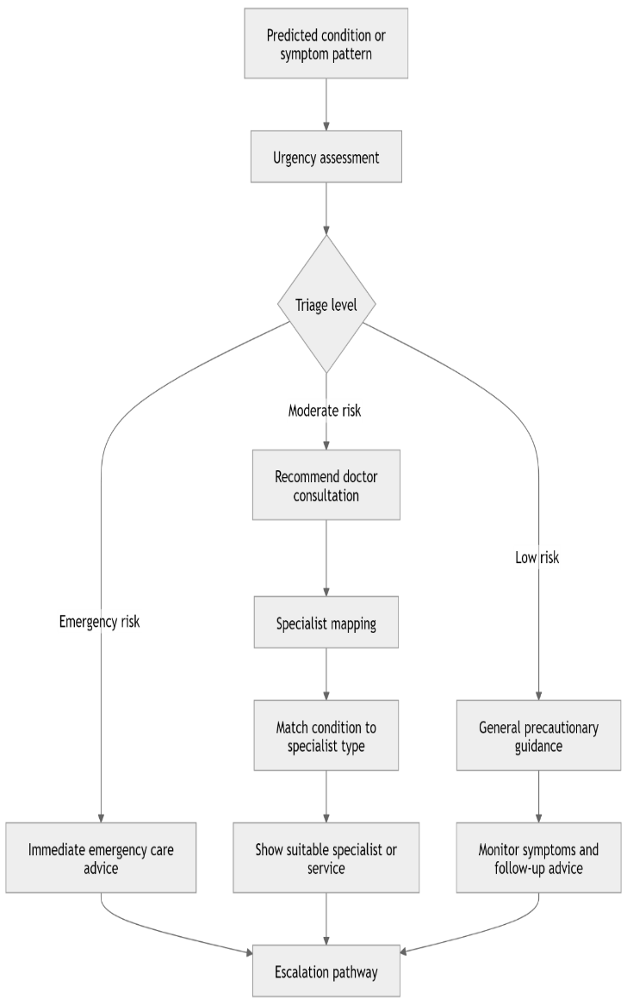
Figure 7. Triage, decision support, and specialist recommendation pathway.
One major issue concern medication-related advice. Some assistant or recommendation-oriented studies move toward medical suggestions or recommendation outputs [11], [12], [21]-[22], [41]-[42]. However, a patient-facing assistant that appears to prescribe or recommend medicine too directly risks crossing into regulatory and professional territory that ordinarily requires clinical oversight, licensing, or formally validated protocols. In practical terms, this means that a smart assistant should be designed to support information, screening, and referral rather than acting as a substitute prescriber. If medication-related content is included at all, it must be tightly constrained, source-grounded, and clearly framed as general guidance rather than personalised prescribing.
A second issue concerns incomplete or weak knowledge bases. If the underlying database lacks sufficient clinical breadth, local relevance, or updated information, the system may produce inaccurate or misleading outputs. This risk is especially serious in symptom-led settings, where the assistant is already working with uncertain, self-reported data [3], [16]-[17], [28], [51]-[53], [60]. Under those conditions, a wrong answer may not only be technically wrong; it may also influence whether the user seeks care, delays care, or selects the wrong specialist. This is why safe assistant design requires explicit uncertainty handling, conservative escalation logic, and refusal boundaries when confidence is too low.
A third issue concerns the handling of abusive, offensive, or manipulative user input. Although this issue is rarely foregrounded in the reviewed studies, it is highly relevant to real-world assistant behaviour. Patient-facing tools must not mirror abusive language, become hostile, or produce unsafe outputs in response to provocation. Instead, they should remain calm, professional, and bounded. In a health context, that means redirecting the interaction toward safe and appropriate support rather than escalating emotionally or generating reckless responses. This requirement is not merely about politeness. It is part of clinical safety, because emotionally reactive systems can undermine trust and increase the risk of harmful guidance.
Privacy and responsibility add a further layer of concern. Smart health assistants may process highly sensitive information about symptoms, risk, and personal health concerns. The literature on healthcare AI repeatedly stresses the importance of trust, transparency, and responsible deployment [10], [15], [27], [43], [55]-[59]. For a patient-facing assistant, this means users should understand what the system is doing, what its limits are, and when a clinician should take over. A clinically responsible assistant should therefore present itself as a support tool, not as an autonomous replacement for medical judgement.

XI Critical Discussion and Research Gap
Generally, the literature is disassembled, the most salient pattern is fragmentation. There are strong building blocks in the literature – foundational reviews clarify the field, structured data and disease specific models show the limits of what machine learning can do under favourable conditions, symptom based models bring the analysis closer to the real user needs, chatbots address communication and referral studies point towards next step navigation [1, 3, 5-6, 10-12, 14, 16, 18, 21, 24, 27, 31, 37, 46, 55-56]. But typically, these abilities are found in stand-alone pieces of work and not in a single, user-friendly framework.
The second pattern is one of a disconnect between predictions and accountability in practice. While many studies address the question of whether the model can classify a disease, fewer address the question of whether the results are interpretable, uncertainty aware, privacy conscious and appropriate for use in first contact in the real world [6], [10], [15], [18]-[20], [27], [43], [48]–[49], [55], [57]–[59]. This undermines the confidence in deployment. But a good assistant is one that isn't just assessed by its back-end capabilities, but also by its approach to situations where information is lacking, where risk is grave, and when the safest bet isn't one that's confidently predicted, but one that involves escalation.
The third pattern is that of the tension between the diagnostic richness and accessibility. Many first contact users do not have imaging or laboratory inputs, which many times are the best technical models available [1, 5]. In comparison, symptom-driven systems are simpler to use, but are more prone to ambiguity, overconfidence and risk in triage [16]-[17], [28], [51]-[53], [60]. But the real challenge of the smart assistant is to fill that gap, and make the information available that much more reliable and usable, without pretending to be anything more than that.
Central research gap thus corresponds to integration. The literature reviewed revealed a significant number of studies focusing on diagnosis and symptom checking, assistant interaction and recommendation, but these did not appear in one complete and clinically responsible system with the symptom taking and estimating the onset of the disease, explaining the symptoms, safe triage, immediate guidance, and specialist mapping. It is the most compelling reason for deeper investigation of using machine learning to create smart health assistants.

XII Limitations of the Review
There are a number of caveats. First, the review did not follow the steps of a multi-database systematic search, but was done on a set of 65 papers, predefined by the authors. In view of this, the review was better thought of as a PRISMA guided structured synthesis than as a de novo systematic review [66]-[68] and PRISMA 2020 was used to reinforce transparency and reporting structure.
Secondly, there are differences in the strength of evidence in the literature base. Some of the studies are systematic reviews or publisher hosted journal articles while others are prototypes, conference type articles or repository hosted versions of the studies. Some evidence was presented more cautiously than others, thus requiring a greater interpretation of the evidence in the review.
Third, there are some thematic areas where there are duplicate reports or where the reports are very similar, particularly in the fields of prediction of chronic diseases, prediction of heart diseases, applications of chatbots, and referral systems. Also, repeated reports were treated with caution and were not considered as substantive new reports, although there is still some overlap between reports, affecting the balance of the existing literature.
Lastly, the content of the review is inter-disciplinary. Smart health assistants are at the intersection of machine learning, human-computer interaction, triage, health communication and clinical governance. It is not possible to adequately cover all those dimensions in one review. Nevertheless, the review is more comprehensive and transparent as a foundation for further research development than a descriptive narrative account.

XIII Conclusion
The literature reviewed demonstrates an active, diverse and promising field with some inconsistencies in the interconnections between the various components. Machine learning algorithms have already proven to be of great value in disease prediction, particularly in disease-specific and structured environment. Capability to support has moved closer to public facing support with symptom-based systems, complaint-based systems, chatbots and recommendation systems. The literature is however still scattered over the areas of diagnostic prediction, conversational support, triage and specialist referral.
The primary conclusion of this review is thus quite evident. The next step is not just another stand-alone classifier, but an integrated smart health assistant, which in addition to symptom-based early assessment with explanation is able to map to specialists in a safe manner. This system needs to be accurate so as to be useful, yet wary of being overzealous and potentially unsafe. It should be used in conjunction with and not instead of clinical judgement.
The evidence reviewed is a good basis for the proposed research direction. It highlights the potential of machine learning as a sound foundation for early health assistance, as well as the need for future systems to be more sensitive to issues of uncertainty, legality, safety, user trust and deployment in real world environments. Those conditions outline what makes the prototype technically interesting versus clinically responsible smart health assistant.

References
[1] “Integrating Machine Learning with Medical Imaging for Human Disease Diagnosis: A Survey.” [Online]. Available: https://www.mdpi.com/2813-0324/10/1/12
[2] “ADD-Net: An Effective Deep Learning Model for Early Detection of Alzheimer Disease in MRI Scans.” [Online]. Available: https://www.researchgate.net/publication/363314569_ADD-Net_An_Effective_Deep_Learning_Model_for_Early_Detection_of_Alzheimer_Disease_in_MRI_Scans
[3] “CoAD: Automatic Diagnosis through Symptom and Disease Collaborative Generation.” [Online]. Available: https://aclanthology.org/2023.acl-long.350/
[4] “Identification and Prediction of Chronic Diseases Using Machine Learning Approach.” [Online]. Available: https://pmc.ncbi.nlm.nih.gov/articles/PMC8896926/
[5] “Development of machine learning model for diagnostic disease prediction based on laboratory tests.” [Online]. Available: https://www.nature.com/articles/s41598-021-87171-5
[6] “Machine Learning Applied to Diagnosis of Human Diseases: A Systematic Review.” [Online]. Available: https://www.annualreviews.org/content/journals/10.1146/annurev.bioeng.8.061505.095802
[7] “A Method for Improving Prediction of Human Heart Disease Using Machine Learning Algorithms.” [Online]. Available: https://onlinelibrary.wiley.com/doi/full/10.1155/2022/1410169
[8] “A Method for Improving Prediction of Human Heart Disease Using Machine Learning Algorithms.” [Online]. Available: https://onlinelibrary.wiley.com/doi/full/10.1155/2022/1410169
[9] “Disease Diagnosis System using Machine Learning.” [Online]. Available: https://www.academia.edu/99264200/Disease_Diagnosis_System_using_Machine_Learning
[10] “Machine-Learning-Based Disease Diagnosis: A Comprehensive Review.” [Online]. Available: https://www.mdpi.com/2227-9032/10/3/541
[11] “Personal Healthcare Chatbot for Medical Suggestions Using Artificial Intelligence and Machine Learning.” [Online]. Available: https://www.researchgate.net/profile/Umapathi-Nagappan/publication/372658029_Section_A-Research_paper_Personal_Healthcare_Chatbot_for_Medical_Suggestions_Using_Artificial_Intelligence_and_Machine_Learning_Eur/links/65279ef33fa934104b1911bd/Section-A-Research-paper-Personal-Healthcare-Chatbot-for-Medical-Suggestions-Using-Artificial-Intelligence-and-Machine-Learning-Eur.pdf
[12] “Disease Prediction and Doctor Recommendation System using Machine Learning Approaches.” [Online]. Available: https://www.researchgate.net/profile/Anand-Kumar-220/publication/353016433_Disease_Prediction_and_Doctor_Recommendation_System_using_Machine_Learning_Approaches/links/60e45592299bf1ea9ee5f3ab/Disease-Prediction-and-Doctor-Recommendation-System-using-Machine-Learning-Approaches.pdf
[13] “Your evidence? Machine learning algorithms for medical diagnosis and prediction.” [Online]. Available: https://onlinelibrary.wiley.com/doi/full/10.1002/hbm.24886
[14] “Development of a Cloud-Based Clinical Decision Support System for Ophthalmology Triage Using Decision Tree Artificial Intelligence.” [Online]. Available: https://pubmed.ncbi.nlm.nih.gov/36439697/
[15] “A Review on the Role of Machine Learning in Enabling IoT Based Healthcare Applications.” [Online]. Available: https://ieeexplore.ieee.org/abstract/document/9355143
[16] “The diagnostic and triage accuracy of digital and online symptom checker tools: a systematic review.” [Online]. Available: https://www.nature.com/articles/s41746-022-00667-w
[17] “Machine learning-based automated classification of headache disorders using patient-reported questionnaires.” [Online]. Available: https://www.nature.com/articles/s41598-020-70992-1
[18] “A Review of AI Based Medical Assistant Chatbot.” [Online]. Available: https://pdfs.semanticscholar.org/2450/12d269075247245a3909197fb847705096b7.pdf
[19] “IntelliDoctor – AI based Medical Assistant.” [Online]. Available: https://ieeexplore.ieee.org/abstract/document/8918778
[20] “A Personalized Medical Assistant Chatbot: MediBot.” [Online]. Available: https://scholar.google.com/scholar?hl=en&as_sdt=0%2C5&q=A+Personalized+Medical+Assistant+Chatbot%3A+MediBot&btnG=
[21] “DocOnTap: AI-based disease diagnostic system and recommendation system.” [Online]. Available: https://scholar.google.com/scholar?hl=en&as_sdt=0%2C5&q=DocOnTap%3A+AI-based+disease+diagnostic+system+and+recommendation+system&btnG=
[22] “AI based Medical Diagnosis with Medicine Recommendation.” [Online]. Available: https://scholar.google.com/scholar?hl=en&as_sdt=0%2C5&q=AI+based+Medical+Diagnosis+with+Medicine+Recommendation&btnG=
[23] “Redesigning Primary Care: The Emergence of Artificial-Intelligence-Driven Symptom Diagnostic Tools.” [Online]. Available: https://scholar.google.com/scholar?hl=en&as_sdt=0%2C5&q=Redesigning+Primary+Care%3A+The+Emergence+of+Artificial-Intelligence-Driven+Symptom+Diagnostic+Tools&btnG=
[24] “Machine-Learning-Based Prediction Modelling in Primary Care: State-of-the-Art Review.” [Online]. Available: https://www.mdpi.com/2673-2688/4/2/24
[25] “A decision support system for primary headache developed through machine learning.” [Online]. Available: https://peerj.com/articles/12743/
[26] “Machine-Learning-Based Disease Diagnosis: A Comprehensive Review.” [Online]. Available: https://scholar.google.com/scholar?hl=en&as_sdt=0%2C5&q=Machine-Learning-Based+Disease+Diagnosis%3A+A+Comprehensive+Review&btnG=
[27] “Machine Learning for Medical Diagnosis: History, State of the Art and Perspective.” [Online]. Available: https://www.sciencedirect.com/science/article/abs/pii/S093336570100077X
[28] “Data analysis in health and big data: A machine learning medical diagnosis model based on patients’ complaints.” [Online]. Available: https://www.tandfonline.com/doi/abs/10.1080/03610926.2019.1622728
[29] “Empathic Chatbot Response for Medical Assistance.” [Online]. Available: https://scholar.google.com/scholar?hl=en&as_sdt=0%2C5&q=Empathic+Chatbot+Response+for+Medical+Assistance&btnG=
[30] “Redesigning Primary Care: The Emergence of Artificial-Intelligence-Driven Symptom Diagnostic Tools.” [Online]. Available: https://www.mdpi.com/2075-4426/13/9/1379
[31] “Machine Learning Applied to Diagnosis of Human Diseases: A Systematic Review.” [Online]. Available: https://www.mdpi.com/2076-3417/10/15/5135
[33] “A Method for Improving Prediction of Human Heart Disease Using Machine Learning Algorithms.” [Online]. Available: https://onlinelibrary.wiley.com/doi/full/10.1155/2022/1410169
[34] “Disease Diagnosis System using Machine Learning.” [Online]. Available: https://www.academia.edu/download/100400815/59755.pdf
[36] “Survey of Machine Learning Algorithms for Disease Diagnostic.” [Online]. Available: https://doc.send2pub.com/id/eprint/181/
[37] “Machine Learning Technology-Based Heart Disease Detection Models.” [Online]. Available: https://onlinelibrary.wiley.com/doi/full/10.1155/2022/7351061
[39] “Human Disease Prediction using Machine Learning Techniques and Real-life Parameters.” [Online]. Available: https://www.researchgate.net/publication/370679044_Human_Disease_Prediction_using_Machine_Learning_Techniques_and_Real-life_Parameters
[40] “Identification and Prediction of Chronic Diseases Using Machine Learning Approach.” [Online]. Available: https://onlinelibrary.wiley.com/doi/full/10.1155/2022/2826127
[41] “Personal Healthcare Chatbot for Medical Suggestions Using Artificial Intelligence and Machine Learning.” [Online]. Available: https://www.researchgate.net/profile/Umapathi-Nagappan/publication/372658029_Section_A-Research_paper_Personal_Healthcare_Chatbot_for_Medical_Suggestions_Using_Artificial_Intelligence_and_Machine_Learning_Eur/links/65279ef33fa934104b1911bd/Section-A-Research-paper-Personal-Healthcare-Chatbot-for-Medical-Suggestions-Using-Artificial-Intelligence-and-Machine-Learning-Eur.pdf
[42] “Disease Prediction and Doctor Recommendation System using Machine Learning Approaches.” [Online]. Available: https://www.researchgate.net/profile/Anand-Kumar-220/publication/353016433_Disease_Prediction_and_Doctor_Recommendation_System_using_Machine_Learning_Approaches/links/60e45592299bf1ea9ee5f3ab/Disease-Prediction-and-Doctor-Recommendation-System-using-Machine-Learning-Approaches.pdf
[43] “Machine-Learning-Based Disease Diagnosis: A Comprehensive Review.” [Online]. Available: https://www.mdpi.com/2227-9032/10/3/541
[44] “Your evidence? Machine learning algorithms for medical diagnosis and prediction.” [Online]. Available: https://onlinelibrary.wiley.com/doi/full/10.1002/hbm.24886
[45] “Development of a Cloud-Based Clinical Decision Support System for Ophthalmology Triage Using Decision Tree Artificial Intelligence.” [Online]. Available: https://www.sciencedirect.com/science/article/pii/S2666914522001208
[46] “Machine-Learning-Based Prediction Modelling in Primary Care: State-of-the-Art Review.” [Online]. Available: https://www.mdpi.com/2673-2688/4/2/24
[47] “A decision support system for primary headache developed through machine learning.” [Online]. Available: https://peerj.com/articles/12743/
[48] “Machine-Learning-Based Disease Diagnosis: A Comprehensive Review.” [Online]. Available: https://www.mdpi.com/2227-9032/10/3/541
[49] “Machine Learning for Medical Diagnosis: History, State of the Art and Perspective.” [Online]. Available: https://www.sciencedirect.com/science/article/abs/pii/S093336570100077X
[50] “Data analysis in health and big data: A machine learning medical diagnosis model based on patients’ complaints.” [Online]. Available: https://www.tandfonline.com/doi/abs/10.1080/03610926.2019.1622728
[51] “Enhancing diagnostic accuracy in symptom-based health checkers: a comprehensive machine learning approach with clinical vignettes and benchmarking.” [Online]. Available: https://www.frontiersin.org/journals/artificial-intelligence/articles/10.3389/frai.2024.1397388/full
[52] “Disease prediction from various symptoms using machine learning.” [Online]. Available: https://ijsrst.com/home/issue/view/article.php?id=IJSRST52310466&utm
[53] “Symptoms Based Multiple Disease Prediction Model using Machine Learning Approach.” [Online]. Available: https://www.researchgate.net/publication/353750269_Symptoms_Based_Multiple_Disease_Prediction_Model_using_Machine_Learning_Approach
[54] “Improving the Accuracy of Medical Diagnosis Detection Using Machine Learning.” [Online]. Available: https://www.researchgate.net/publication/392988875_Improving_the_Accuracy_of_Medical_Diagnosis_Detection_using_Machine_Learning
[55] “The Significance of Machine Learning in Clinical Disease Diagnosis: A Review.” [Online]. Available: https://www.researchgate.net/publication/375060519_The_Significance_of_Machine_Learning_in_Clinical_Disease_Diagnosis_A_Review
[56] “Healthcare predictive analytics using machine learning and deep learning techniques: a survey.” [Online]. Available: https://www.researchgate.net/publication/362343435_Healthcare_Predictive_Analytics_Using_Machine_Learning_and_Deep_Learning_Techniques_A_Survey
[57] “A Comparative Study of Machine Learning Algorithms for Medical Diagnosis.” [Online]. Available: https://www.researchgate.net/publication/378977140_A_Comparative_Analysis_of_Machine_Learning_Algorithms_for_Predictive_Analytics_in_Healthcare
[58] “Delving into Machine Learning’s Influence on Disease Diagnosis and Prediction.” [Online]. Available: https://openpublichealthjournal.com/contents/volumes/V17/e18749445297804/e18749445297804.pdf
[59] “Predictive Analytics using Machine Learning for Healthcare Diagnostics.” [Online]. Available: https://www.researchgate.net/publication/389771372_Predictive_Analytics_and_Machine_Learning_in_Healthcare_A_Comprehensive_Framework_for_Clinical_Implementation
[60] “Enhancing diagnostic accuracy in symptom-based health checkers: a comprehensive machine learning approach with clinical vignettes and benchmarking.” [Online]. Available: https://www.researchgate.net/publication/384512151_Enhancing_diagnostic_accuracy_in_symptom-based_health_checkers_a_comprehensive_machine_learning_approach_with_clinical_vignettes_and_benchmarking
[61] “Survey of Machine Learning Algorithms for Disease Diagnostic.” [Online]. Available: https://www.researchgate.net/publication/312629315_Survey_of_Machine_Learning_Algorithms_for_Disease_Diagnostic
[62] “Machine Learning Technology-Based Heart Disease Detection Models.” [Online]. Available: https://www.researchgate.net/publication/358897643_Machine_Learning_Technology-Based_Heart_Disease_Detection_Models
[63] “Identification and Prediction of Chronic Diseases Using Machine Learning Approach.” [Online]. Available: https://www.researchgate.net/publication/358872547_Identification_and_Prediction_of_Chronic_Diseases_Using_Machine_Learning_Approach
[64] “Human Disease Prediction using Machine Learning Techniques and Real-life Parameters.” [Online]. Available: https://www.researchgate.net/publication/370679044_Human_Disease_Prediction_using_Machine_Learning_Techniques_and_Real-life_Parameters
[65] “Identification and Prediction of Chronic Diseases Using Machine Learning Approach.” [Online]. Available: https://www.researchgate.net/publication/358872547_Identification_and_Prediction_of_Chronic_Diseases_Using_Machine_Learning_Approach
[66] M. J. Page, J. E. McKenzie, P. M. Bossuyt, I. Boutron, T. C. Hoffmann, C. D. Mulrow, et al., “The PRISMA 2020 statement: an updated guideline for reporting systematic reviews,” BMJ, vol. 372, p. n71, 2021, doi: 10.1136/bmj.n71.
[67] M. J. Page, D. Moher, P. M. Bossuyt, I. Boutron, T. C. Hoffmann, C. D. Mulrow, et al., “PRISMA 2020 explanation and elaboration: updated guidance and exemplars for reporting systematic reviews,” BMJ, vol. 372, p. n160, 2021, doi: 10.1136/bmj.n160.
[68] PRISMA Executive, “PRISMA 2020 flow diagram,” PRISMA Statement, 2026. [Online]. Available: https://www.prisma-statement.org/prisma-2020-flow-diagram

